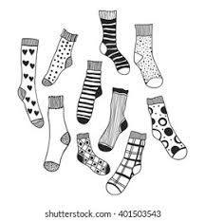
Women of Faith are collecting new socks during the month of December to donate to the City Rescue Mission. The basket for these is under the table in the Narthex that has the laundry basket on it.

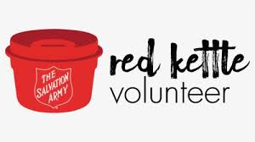

We are ringing the bell again this year at the Publix’s on University Blvd. Our day is Saturday, December 10th from 10 am to 8 pm. We always have a good time doing this and if you have not volunteered to do this before, please consider signing up this time. Susan Davis will have the sign up sheet for you to choose a time.

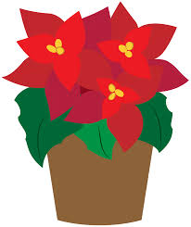

The poinsettia order form will be in the bulletin next week. This year we will have the flowers in the sanctuary for Christmas Eve and for Christmas Day service which is on a Sunday.

November 27, 2022

Psalm 122

¹ I was glad when they said to me,
“let us go to the house of the Lord!”
² Our feet are standing
within your gates, O Jerusalem.
³ Jerusalem is built as a city
and is bound firmly together.
⁴ To which the tribes go up,
the tribes of the Lord,
to give thanks to the name of the Lord.
as was decreed for Israel,
⁵ Thrones for judgment were set there,
the thrones of the house of David.
⁶ Pray for the peace of Jerusalem:
“may they prosper who love you.
⁷ Peace be within your walls
and security within your towers.”
⁸ For the sake of my relatives and friends
I will say, “Peace be within you.”
⁹ For the sake of the house of the Lord our God,
I will seek your good.

Isaiah 2: 1-5
The word that Isaiah the son of Amoz saw concerning Judah and Jerusalem.
² Now it shall come to pass in the latter days
That the mountain of the Lord’s house
Shall be established on the top of the mountains,
And shall be exalted above the hills;
And all nations shall flow to it.
³ Many people shall come and say,
“Come, and let us go up to the mountain of the Lord,
To the house of the God of Jacob;
He will teach us His ways,
And we shall walk in His paths.”
For out of Zion shall go forth the law,
And the word of the Lord from Jerusalem.
⁴ He shall judge between the nations,
And rebuke many people;
They shall beat their swords into plowshares,
And their spears into pruning hooks;
Nation shall not lift up sword against nation,
Neither shall they learn war anymore.
⁵ O house of Jacob, come and let us walk
In the light of the Lord.

Romans 13: 11-14

¹¹ And do this, knowing the time, that now it is high time to awake out of sleep; for now our salvation is nearer than when we first believed. ¹² The night is far spent, the day is at hand. Therefore, let us cast off the works of darkness, and let us put on the armor of light. ¹³ Let us walk properly, as in the day, not in revelry and drunkenness, not in lewdness and lust, not in strife and envy. ¹⁴ But put on the Lord Jesus Christ, and make no provision for the flesh, to fulfill its lusts.

St Matthew 24: 36-44

³⁶ “But of that day and hour no one knows, not even the angels of heaven, but My Father only. ³⁷ But as the days of Noah were, so also will the coming of the Son of Man be. ³⁸ For as in the days before the flood, they were eating and drinking, marrying and giving in marriage, until the day that Noah entered the ark, ³⁹ and did not know until the flood came and took them all away, so also will the coming of the Son of Man be. ⁴⁰ Then two men will be in the field: one will be taken and the other left. ⁴¹ Two women will be grinding at the mill: one will be taken and the other left. ⁴² Watch therefore, for you do not know what hour your Lord is coming. ⁴³ But know this, that if the master of the house had known what hour the thief would come, he would have watched and not allowed his house to be broken into. ⁴⁴ Therefore you also be ready, for the Son of Man is coming at an hour you do not expect.

